PORTAL GUIDE

1. Open your internet browser, on the right side of the Tribunet home page you will see "Comparative Review Portal" (see below).

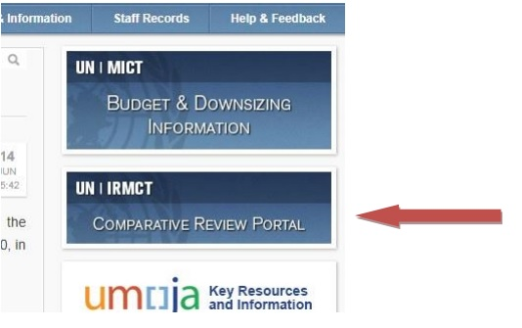

2. Click on "Comparative Review Portal". Your personal data should appear (see example below).

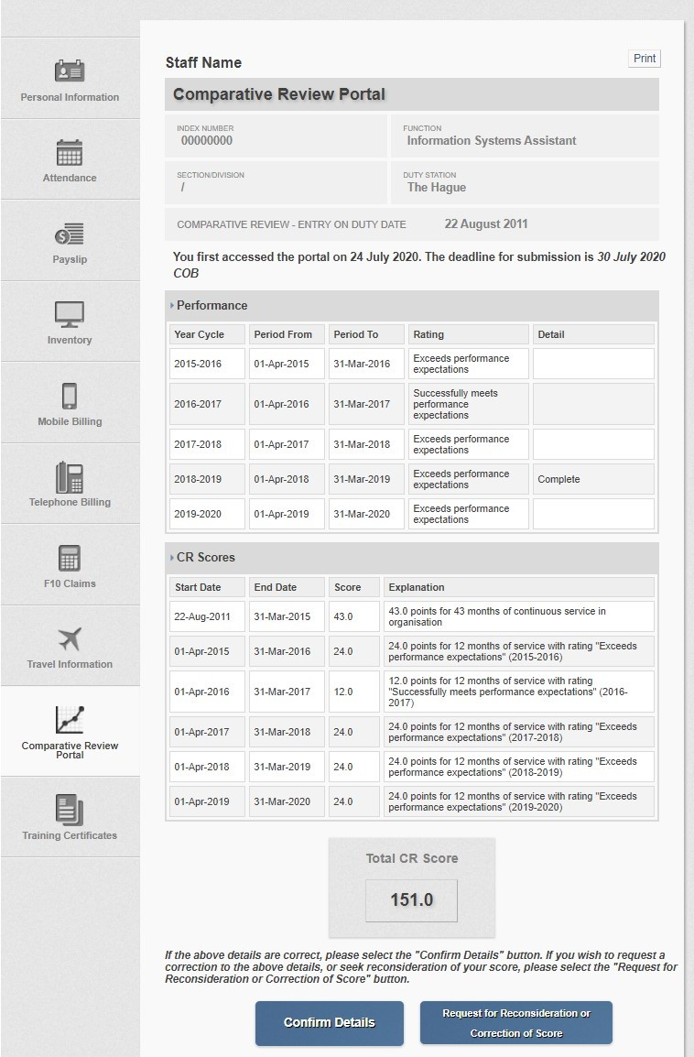

3. If your information is correct please click “Confirm Details”. If you believe it is not correct, please click “Request for Reconsideration or Correction of Score” (see below).

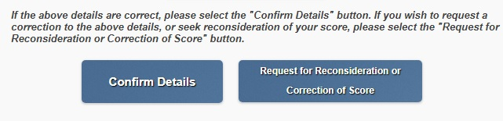

4. If you clicked “Confirm Details” you will receive a confirmation as follows:

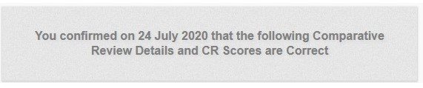

5. If you have clicked “Request for Reconsideration or Correction of Score” you will have the option to provide a description of requested corrections and provide supporting documentation within the portal (see below).

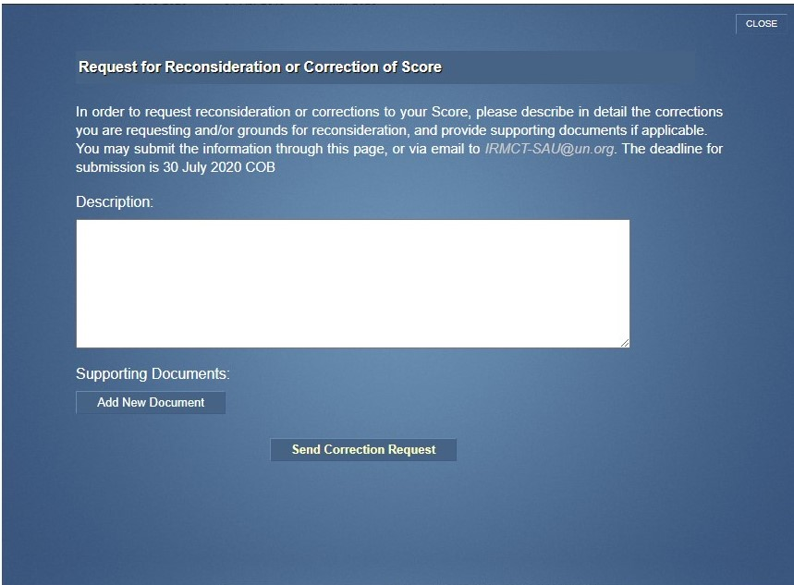

6. You may enter your information immediately, or you may close the browser window and return to the Portal at a later date to enter the information (within the 5 day deadline for review). Once you click “Send Correction Request” you will receive a confirmation as follows:

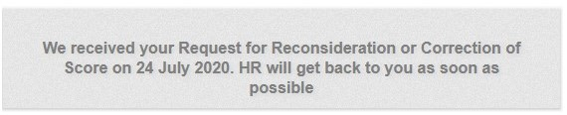

7. Alternatively, you may submit your request and supporting documents to Staff Administration
Unit via email to irmct-sau@un.org. SAU will confirm receipt of your email.

8. Human Resources will review your request for reconsideration or correction, and follow-up with you directly. If the matter is one that can be resolved by Human Resources, we will do so in consultation with you. Otherwise, Human Resources will forward the matter to the Review Board in accordance with the Mechanism Downsizing Policy,section III.A.2.

9. For any other Portal and Score related query please contact Human Resources via IRMCT-SAU e-mail (irmct-sau@un.org).

